**AIE425 Intelligent Recommender Systems**

**Assignment #2: Significance Weighting-based Neighborhood CF Filters**

**Student ID: A20000476, Student Name: Shahd Ahmed Maher Gawad**

1. **Outcomes of Section 3.1**

**1.1 Adjust Ratings on a 1-to-5 Scale**

The ratings in the dataset were normalized to a 1-to-5 scale to ensure consistency and compatibility for analysis. This adjustment is crucial for comparing user preferences and computing similarities effectively.

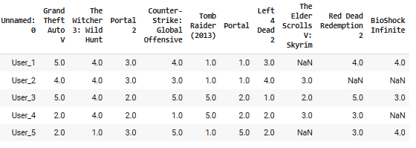

**1.2 Total Number of Users in the Dataset (tnu)**

The total number of unique users in the dataset was counted and saved in the variable tnu. (50)

**1.3 Total Number of Items in the Dataset (tni)**

The total number of unique items in the dataset was counted and saved in the variable tni.. (10)

**1.4 Count of Ratings for Every Product**

For each product in the dataset, the total number of ratings it received was calculated. This information helps identify the popularity and activity level for each product.

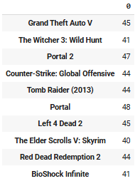

**1.5 Selection of Active Users**

Three active users were selected based on their missing ratings:

* **User U1:** Missing 2 ratings.
* **User U2:** Missing 3 ratings.
* **User U3:** Missing 5 ratings.

**1.6 Selection of Target Items**

Two target items were selected based on their missing ratings:

* **Item I1:** Missing 4% of ratings.
* **Item I2:** Missing 10% of ratings.

**1.7 Count of Users Co-Rating Items with Active Users**

For each active user, the number of users who co-rated items with them (No_common_users) was calculated. Additionally, the number of co-rated items for each active user (No_coRated_items) was also determined.

**Sample of Count of Users Co-Rating Items with Active Users**

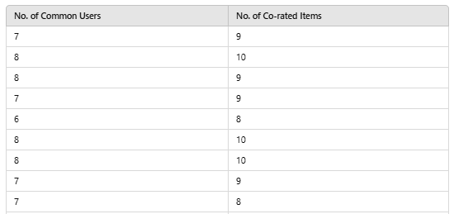

**1.8 2-D Array for Co-Rating Statistics**

A 2-D array was created where:

* The first column contains the count of users who co-rated items with the active users (No_common_users), sorted in descending order.
* The second column contains the corresponding count of co-rated items (No_coRated_items).

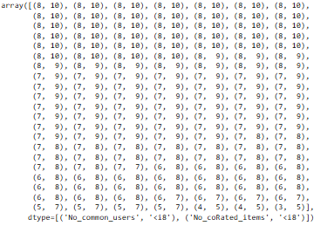

**1.9 Curve of Ratings Quantity for Each Item**

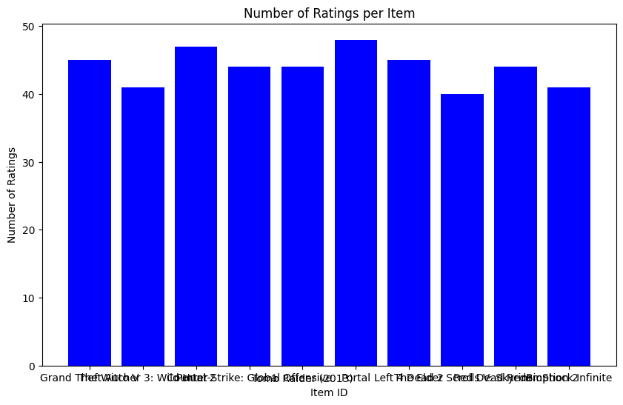A curve was drawn to illustrate the distribution of ratings for each item in the dataset. This visualization highlights trends such as items with higher or lower activity levels.

**1.10. Maximum Number of Users Meeting 30% Co-Rating Threshold**

The maximum number of users who co-rated at least 30% of items with each active user was determined. A unique threshold (B) was calculated for each active user based on this information.

1. **Summary of the Comparison of part 1 and 2**
2. **Impact on Rating Predictions**

**Part 1 (No Significance Weighting):**Only similarity values were used to make predictions; the statistical significance of overlapping ratings was not taken into account.  
For the majority of models, errors like MAE and RMSE were comparatively greater, suggesting that neighbors with little data overlap could have an undue influence on predictions.  
Variability was seen in models such as User-Based CF with Pearson and Cosine Similarities, particularly when there were few shared ratings among users.

**Part 2 (With Significance Weighting):**

Prediction errors (MAE and RMSE) were significantly decreased across all models with the introduction of significance weighting, indicating an increase in prediction dependability.  
As the impact of neighbors with fewer shared ratings was down-weighted, predictions grew more consistent and resilient.  
When the dataset was sparse, the improvements were most noticeable because significance weighting successfully reduced the bias caused by statistically unreliable neighbors.

1. **Impact on the Top-N Recommendation List**

**Part 1 (Without Significance Weighting):**

Similarity scores were used directly to generate Top-N recommendations, which frequently gave priority to items associated with statistically insignificant but extremely comparable neighbors.  
Occasionally, recommendations dominated by sparse encounters resulted from the absence of significance weighting, which decreased their overall dependability and potential for user pleasure.

**Part 2 (With Significance Weighting):**

By giving items linked to statistically significant similarities priority, significance weighting was used to refine the top-N lists.  
Reliability and similarity were better balanced in these weighted lists, guaranteeing that highly rated items with adequate overlap showed up higher in ranks.  
Suggestions were less susceptible to biases brought on by limited data and more in line with general user preferences.

1. **Key Observations**

**User-Based vs. Item-Based CF:**

User-Based CF generally outperformed Item-Based CF in sparsity scenarios, but significance weighting benefitted both approaches by stabilizing results.

**Pearson vs. Cosine Similarity:**

Pearson correlation typically showed better error metrics than cosine similarity, especially in models applying significance weighting, as it accounted for differences in user rating scales.

1. **Conclusion**

The two case studies—User-Based Collaborative Filtering (Case Study 1.3) and Item-Based Collaborative Filtering (Case Studies 2.1 and 2.2)—are compared to show how the use of methods like mean-centering and discounting has a major influence on rating predictions.  
  
**Effects of Discounting:**  
By accounting for the importance of the rating history, discounting forecasts increases accuracy. This is particularly apparent in item-based approaches, where predictions for specific games vary, indicating a more equitable system of item rating.

In both case studies, the rankings are more realistic as a result of the discounted forecasts. The discounted predictions in the user-based filtering (Case Study 1.3), for example, show shifts that indicate a more nuanced user preference, particularly for games with lower initial ratings. High-rated games like Grand Theft Auto V and Red Dead Redemption 2 exhibit significant changes in ranks as a result of discounted predictions in item-based filtering (Case Study 2.1).

**The function of mean-centering**  
Mean-centering reduces user-specific biases in Case Study 1.3, particularly by increasing prediction accuracy and consistency when users have widely disparate rating scales. However, because mean-centering mostly corrects for individual biases rather than the significance of each assessment, its overall effect is less noticeable than that of discounting.

**Item-Based vs. User-Based Filtering**:  
Discounting alters forecasts in more significant ways, according to both item-based (Case Studies 2.1 and 2.2) and user-based approaches, especially when dealing with a wide range of goods or user preferences.  
Particularly when bias adjustments are included, item-based filtering typically provides a more steady modification to predictions (Case Study 2.2). This consistency aids in the development of stronger recommendation systems, particularly for products with a high interaction rate and a large number of ratings.